DISASTER RECOVERY USING ALWAYSON AVAILABILITY GROUP – SCENARIO 1
https://jbswiki.com/2017/08/03/disaster-recovery-using-alwayson-availability-group-scenario-1/
Environment:

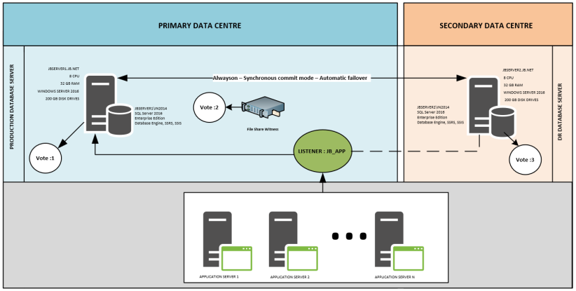
-> Disaster Recovery scenario is as below,
- PRIMARY DATA CENTRE goes down.
- The databases on Server JBSERVER2 should be made online and have the application connect to Database Server JBSERVER2.
- Failback Availability group back to JBSERVER1 when PRIMARY DATA CENTRE comes online.
- The changes made by the Application on JBSERVER2\IN2014 should be relayed to JBSERVER1\IN2014
-> Checking the current AlwaysON setup in SQL Server Management Studio,
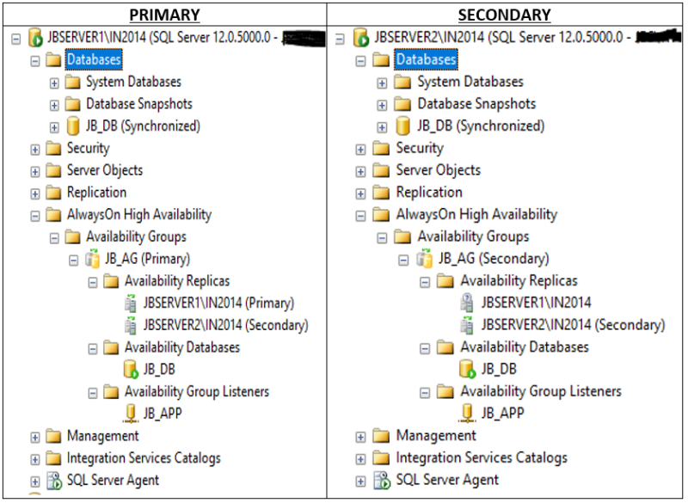
-> The Database JB_DB contains a table named Table5, which we will use for testing.

USE [JB_DB]
GO
CREATE TABLE [dbo].[Table5](
[sno] [int] IDENTITY(1,1) NOT NULL,
[sname] [char](2000) NULL,
[sname1] [char](2000) NULL,
[sname2] [char](2000) NULL,
PRIMARY KEY CLUSTERED
(
[sno] ASC
)WITH (PAD_INDEX = OFF, STATISTICS_NORECOMPUTE = OFF, IGNORE_DUP_KEY = OFF, ALLOW_ROW_LOCKS = ON, ALLOW_PAGE_LOCKS = ON) ON [PRIMARY]
) ON [PRIMARY]

Set nocount on
insert into Table5 values (‘a’,’b’,’c’)
go 10002
-> Checking the row count for object Table5,
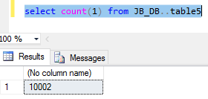
-> The PRIMARY DATA CENTRE goes down. 2 votes are lost as Database Server JBSERVER1 and file share witness is down. Now that 2 votes out of 3 votes are lost, the cluster goes down.
-> Checking the SQL Server instance and Eventlogs on JBSERVER2 when the Primary Data Centre is down.
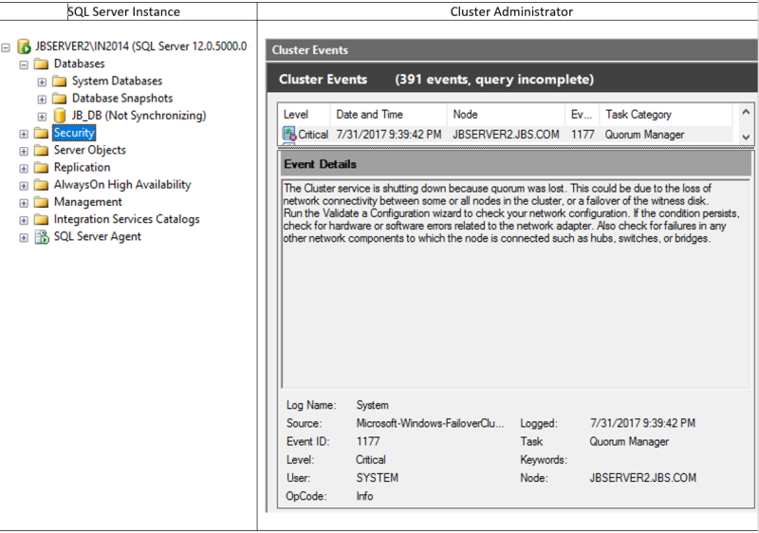
-> Implementing Force Quorum on JBSERVER2.
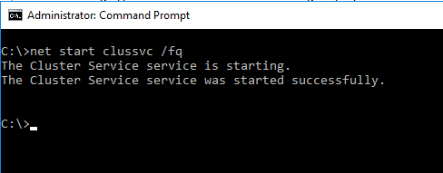
-> Checking the SQL Server Instance after Force Quorum,
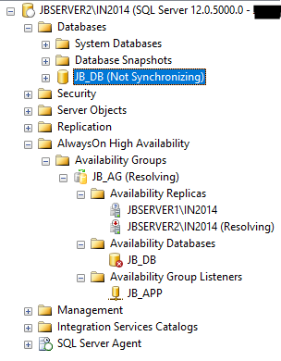
-> I will suspend the data movement now,
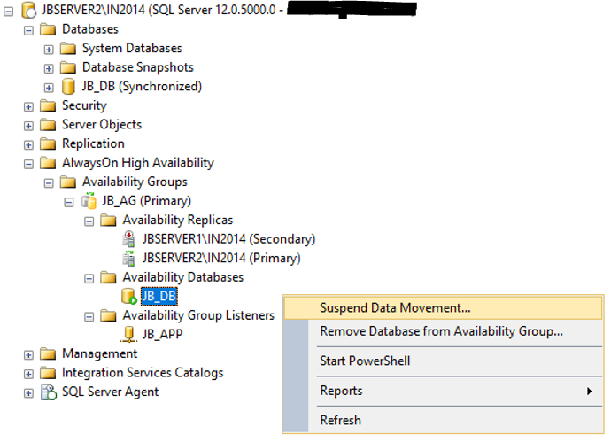
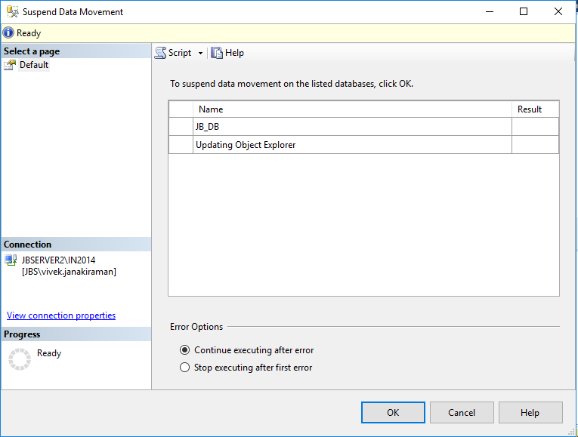
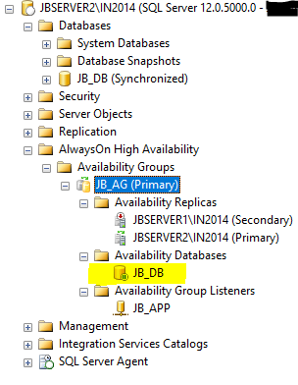

-> Right-click the availability group to be failed over, and select Failover.
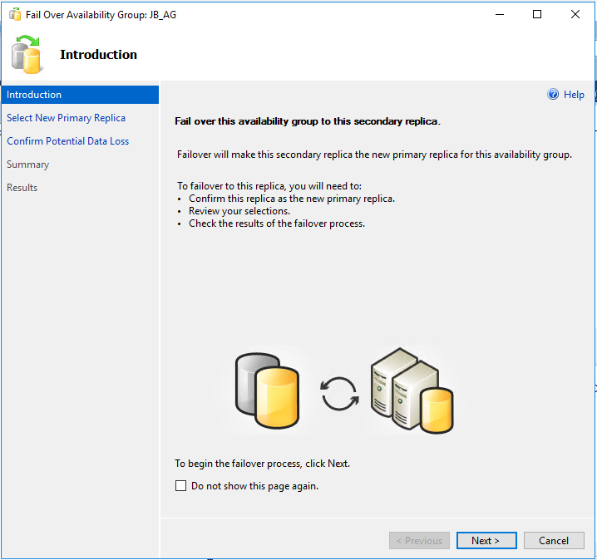
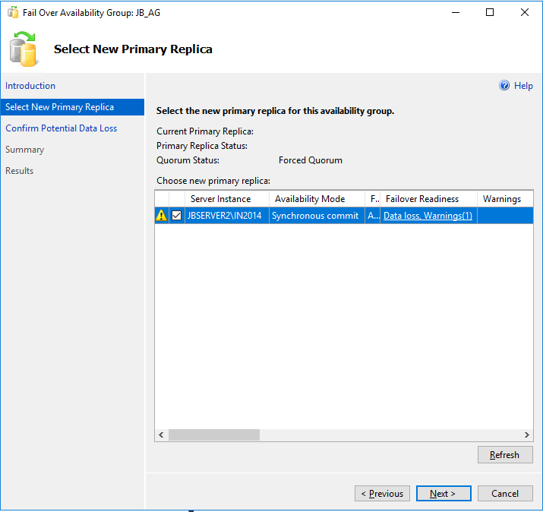
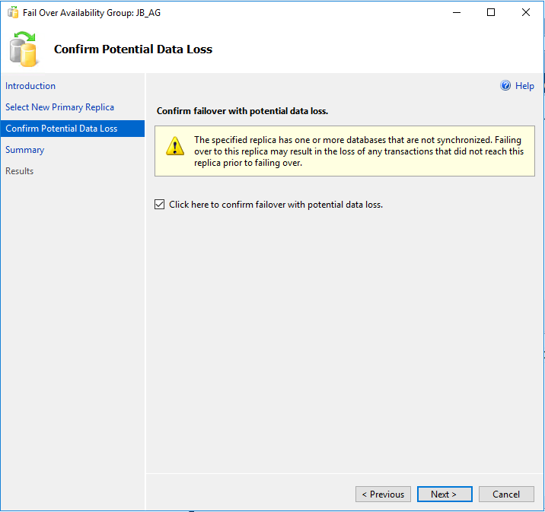
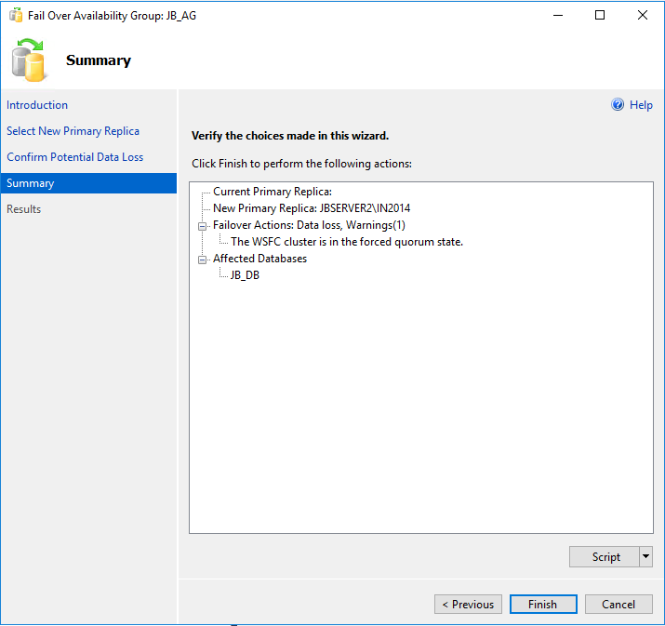
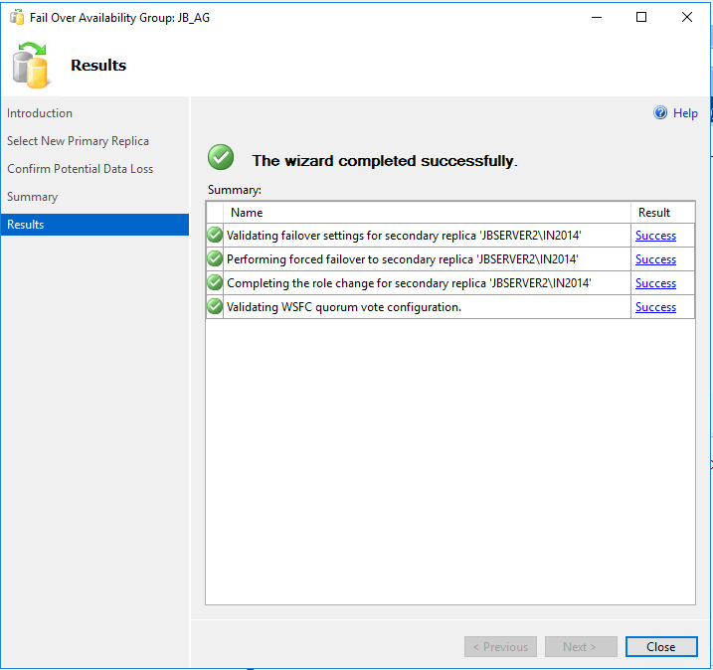
-> Checking the SQL Server Instance after the failover with data loss.
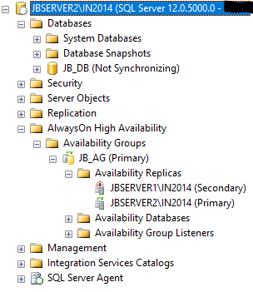
-> The application can now connect to SQL Server Instance JBSERVER2\IN2014 using the Listener and use it. Let us insert a single row to the table for testing and make sure if it can be seen later after the failback.

insert into Table5 values (‘a’,’b’,’c’)
go
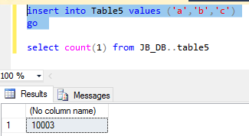
-> The PRIMARY DATA CENTRE comes online. Database Server JBSERVER1 and File witness are online now.
-> Connecting to JBSERVER1\IN2014 and Suspending the data movement,
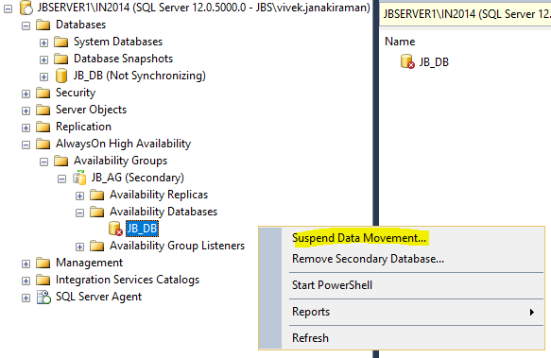
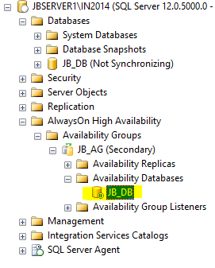
-> On SQL Server Instance JBSERVER2\IN2014, we will resume the data movement.
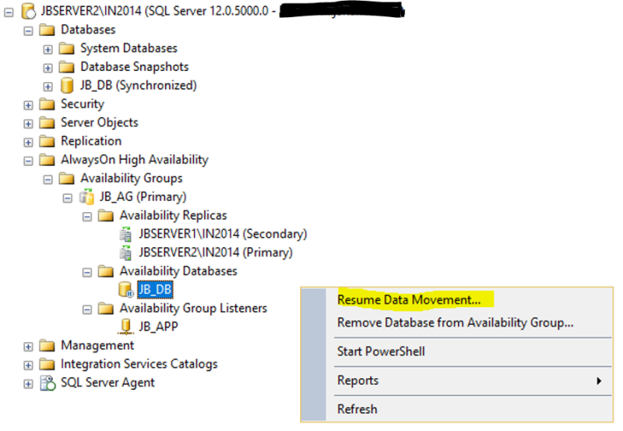
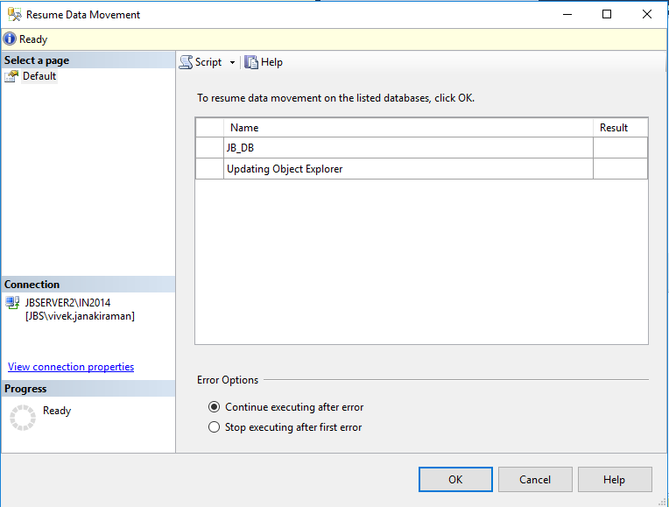
-> On SQL Server Instance JBSERVER1\IN2014, we will resume the data movement.
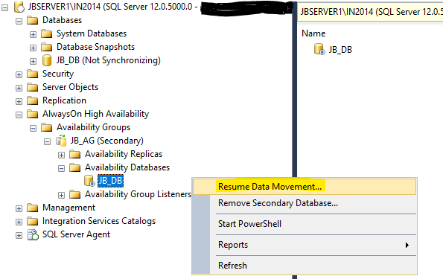
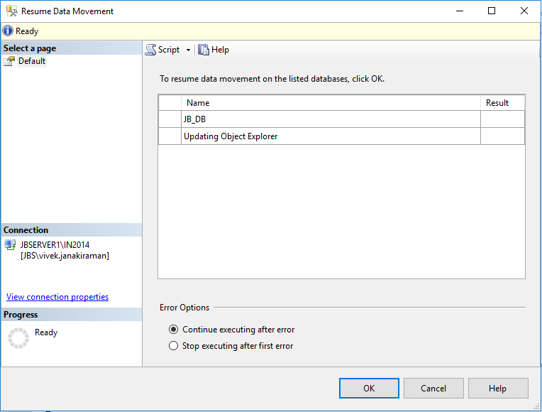
-> Checking the SQL Server Instance now,
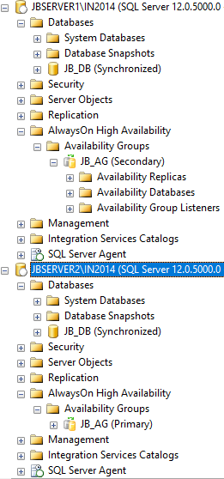

-> We will failback the Alwayson Availability group to JBSERVER1\IN2014,
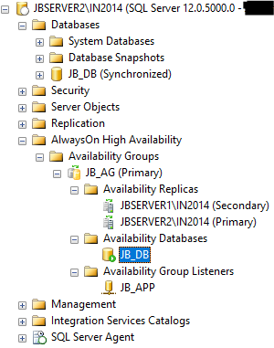
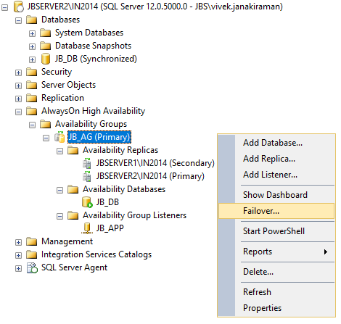
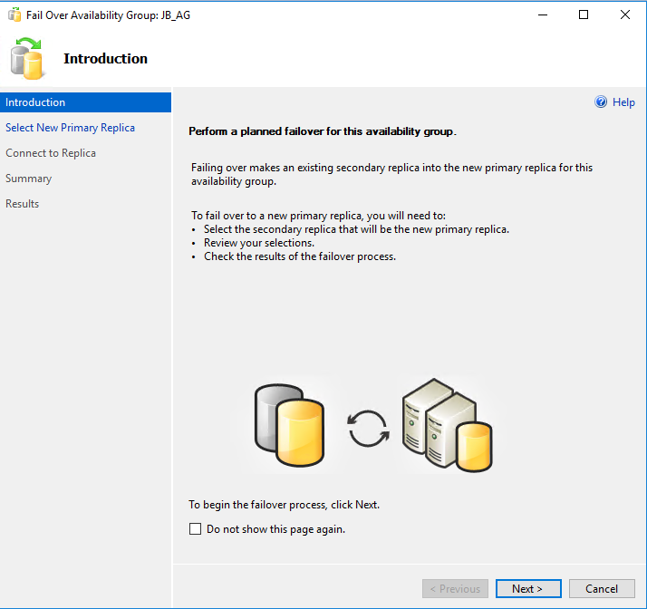
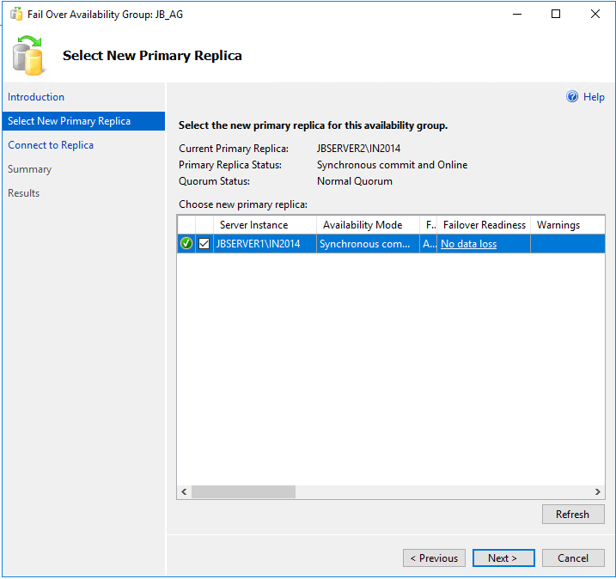
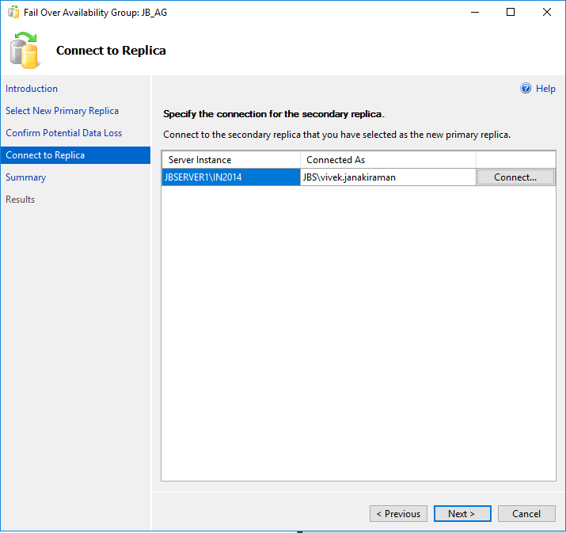
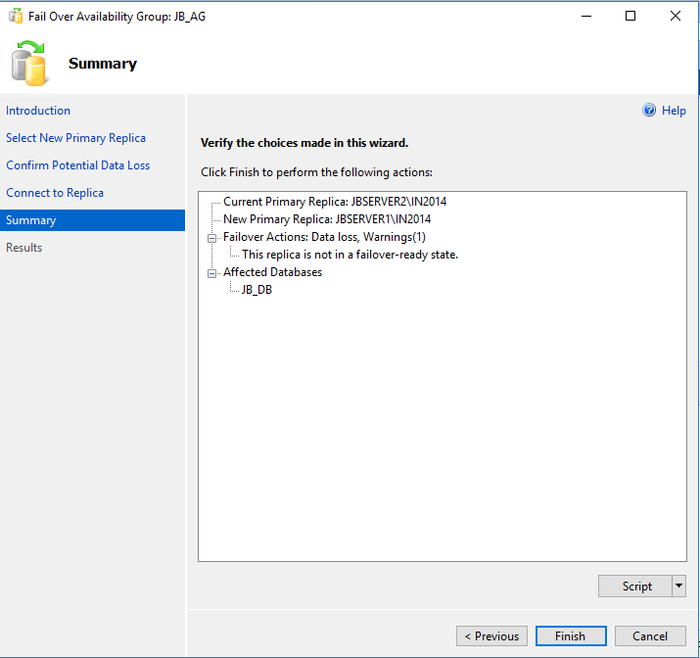
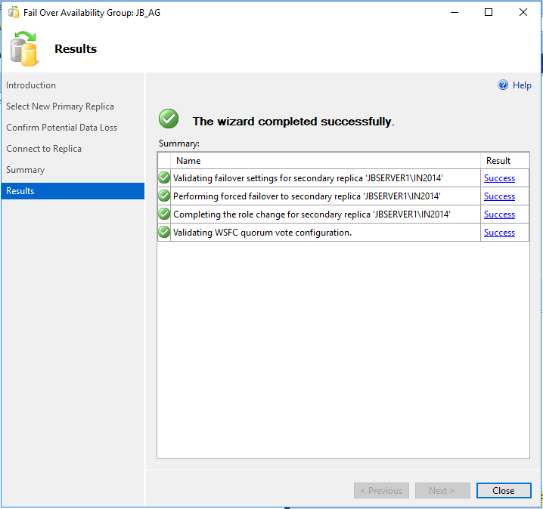
-> Checking the row count for object Table5 on JBSERVER1\IN2014 after failback,
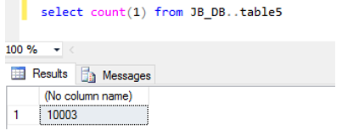
Thank You,
Vivek Janakiraman
https://jbswiki.com/2017/08/03/disaster-recovery-using-alwayson-availability-group-scenario-1/

DISASTER RECOVERY USING ALWAYSON AVAILABILITY GROUP – SCENARIO 2
https://jbswiki.com/2017/08/03/disaster-recovery-using-alwayson-availability-group-scenario-2/
Environment

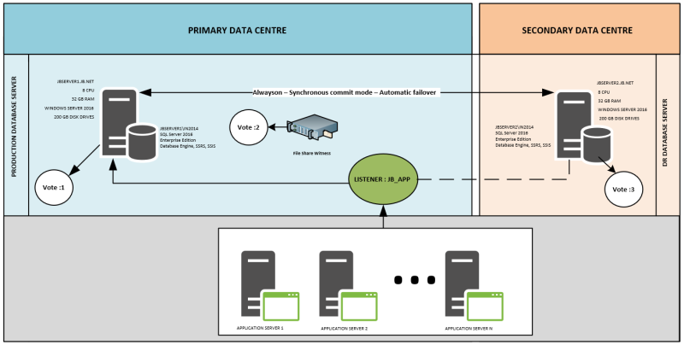-> Disaster Recovery scenario is as below,
- PRIMARY DATA CENTRE goes down.
- The databases on Server JBSERVER2 should be made online and have the application connect to Database Server JBSERVER2.
- Failback Availability group back to JBSERVER1 when PRIMARY DATA CENTRE comes online.
- The changes made by the Application on JBSERVER2\IN2014 should be discarded.
-> Checking the current AlwaysON setup in SQL Server Management Studio,
-> The Database JB_DB contains a table named Table5, which we will use for testing.

USE [JB_DB]
GO
CREATE TABLE [dbo].[Table5](
[sno] [int] IDENTITY(1,1) NOT NULL,
[sname] [char](2000) NULL,
[sname1] [char](2000) NULL,
[sname2] [char](2000) NULL,
PRIMARY KEY CLUSTERED
(
[sno] ASC
)WITH (PAD_INDEX = OFF, STATISTICS_NORECOMPUTE = OFF, IGNORE_DUP_KEY = OFF, ALLOW_ROW_LOCKS = ON, ALLOW_PAGE_LOCKS = ON) ON [PRIMARY]
) ON [PRIMARY]

Set nocount on
insert into Table5 values (‘a’,’b’,’c’)
go 10002
-> Checking the row count for object Table5,
-> The PRIMARY DATA CENTRE goes down. 2 votes are lost as Database Server JBSERVER1 and file share witness is down. Now that 2 votes out of 3 votes are lost, the cluster goes down.
-> Checking the SQL Server instance and Eventlogs on JBSERVER2 when the Primary Data Centre is down.
-> Implementing Force Quorum on JBSERVER2.
-> Checking the SQL Server Instance after Force Quorum,
-> I will suspend the data movement now,
-> Right-click the availability group to be failed over, and select Failover.
-> Checking the SQL Server Instance after the failover with data loss.
-> The application can now connect to SQL Server Instance JBSERVER2\IN2014 using the Listener and use it. Let us insert a single row to the table for testing and make sure if it can be seen later after the failback.

insert into Table5 values (‘a’,’b’,’c’)
go
-> The PRIMARY DATA CENTRE comes online. Database Server JBSERVER1 and File witness are online now.
-> Connecting to JBSERVER1\IN2014 and Suspending the data movement,

-> We will failback the Alwayson Availability group to JBSERVER1\IN2014,
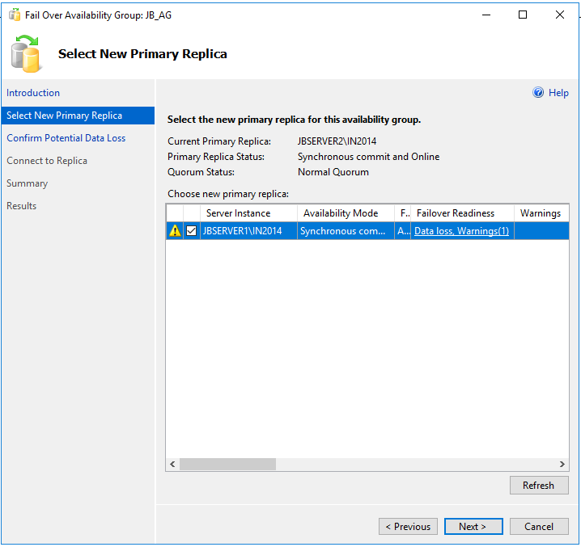
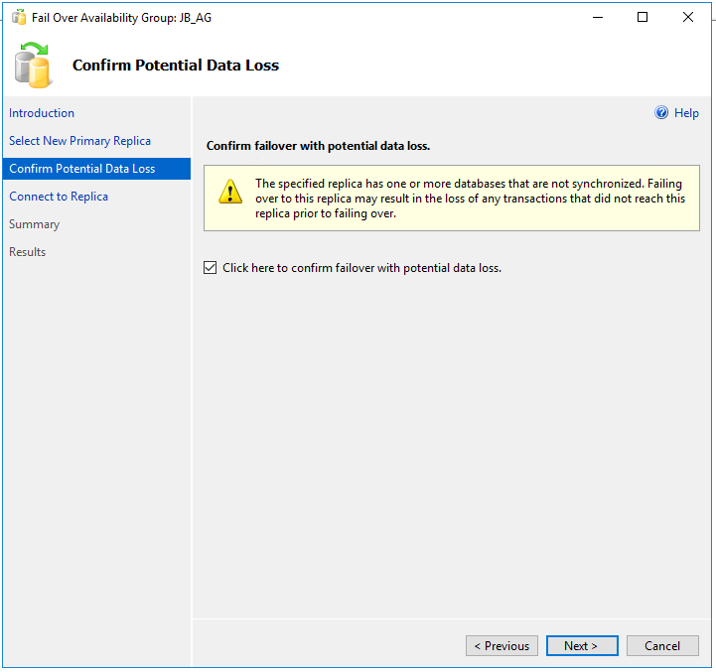
-> On SQL Server Instance JBSERVER1\IN2014, we will resume the data movement.
-> On SQL Server Instance JBSERVER2\IN2014, we will resume the data movement.
-> Checking the SQL Server Instance now,
-> Checking the row count for object Table5 on JBSERVER1\IN2014 after failback,

